Notes to update OnSpeed WiFi by WiFi.

Navigate to ~\Arduino\OnSpeedWiFi folder and double click on latest OnSpeedWifi.ino file. This will launch Arduino app.

Arduino must be configured for WiFi and not Teensy.

In the menu select TOOLS > Board > ESP32 Pico Kit if it is not already selected. (Expect Arduino app to have the last board used selected.)

Scroll down in the OnSpeedWifi tab to find:

String wifi_fw=”?.?.?”; // wifi firmware version. Make a note of the number ?.?.? to make sure update is successful.

Now Export compiled Binary file by selecting SKETCH > Export compiled Binary file. This will take several minutes to compile the file and write it to your ~\Arduino\OnSpeedWiFi folder. A “Don compiling.” message will appear near the bottom of your Arduino app window and the file will be written to your ~\OnSpeedWiFi folder.

Login to your iCloud Drive using your web browser. (Some people may have iCloud for windows installed on their computer and can move the BIN file that way.) Enter your Apple ID, Check Box “Keep me signed in” if you like, Enter your Apple ID Password, if using 2-Factor identification like I am, you will be asked to enter a number that Apple sends you to sign in on a new device.

Now that you are logged into your iCloud account, click the icon for the iCloud Drive. At the top of the iCloud Drive screen there is an arrow pointing into a cloud. Click that icon to upload your file to iCloud Drive. A window will appear to navigate to the BIN file in ~\OnSpeedWiFi directory. Double Click the OnSpeedWifi.ino.pico32..bin file. The file should now be stored in your iCloud.

Your iPhone need to be on your local WiFi network. On your iPhone, select your Files icon.

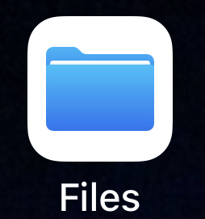

IF you do not know where your Files are located, touch your finger to the middle of your iPhone screen and while touching, slide your finger down toward the bottom of the screen. Type in the search box at the top of the screen Files. You should see your Files Icon appear under Applications at the bottom ½ of the screen. Select Files. On the iCloud Drive screen, you should see all the files that you saw on your computer browser window.

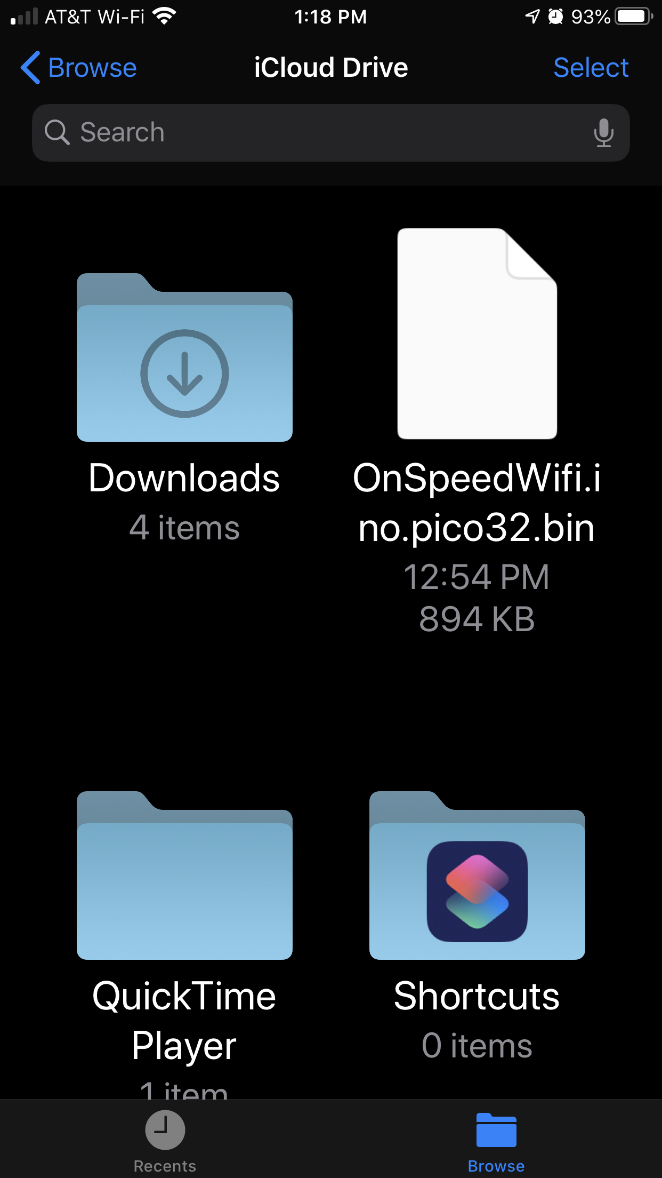

The OnSpeedWifi.ino.pico32.bin file should be there but there is a little cloud with an arrow pointing down out of it. Touch that file to download to your device.

The file is now on your iPhone to upload to your OnSpeed Gen 2 V3 device.

With your OnSpeed Gen 2 V3 device powered on, go to settings on your iPhone, select WiFi, and select OnSpeed network.

Open your iPhone browser load the onspeed.local page.

Under Tools select Upgrade WiFi module.

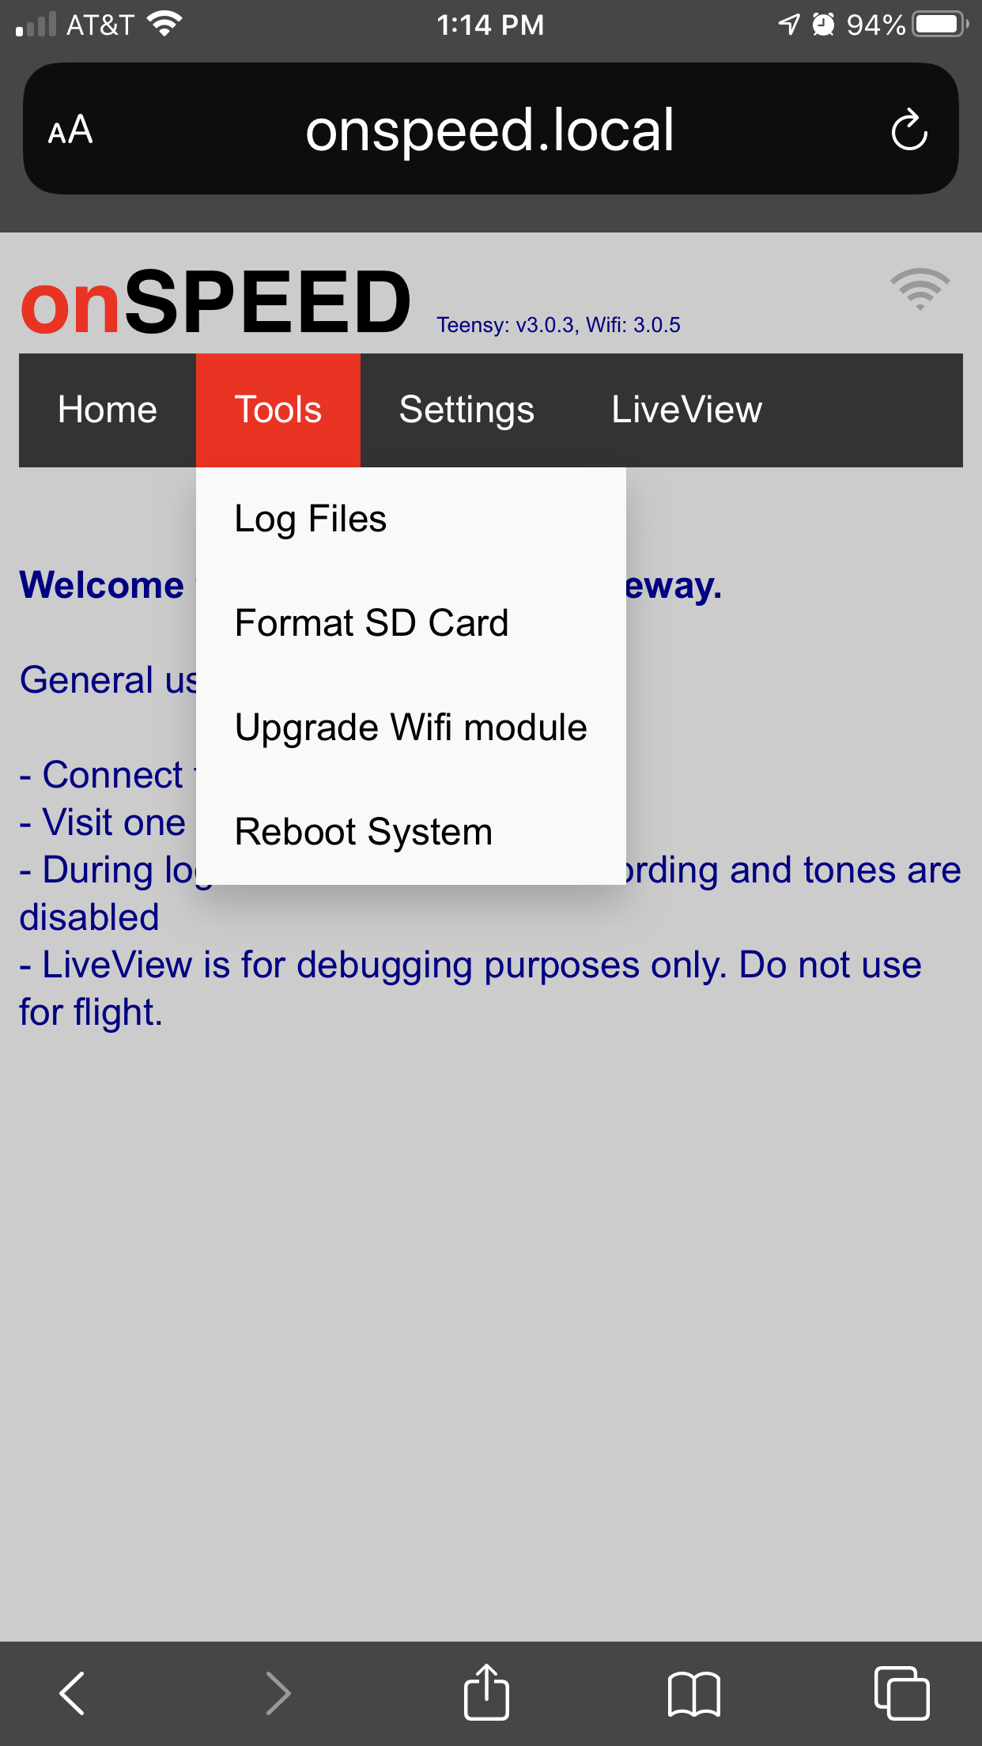

Touch the Chose File button.

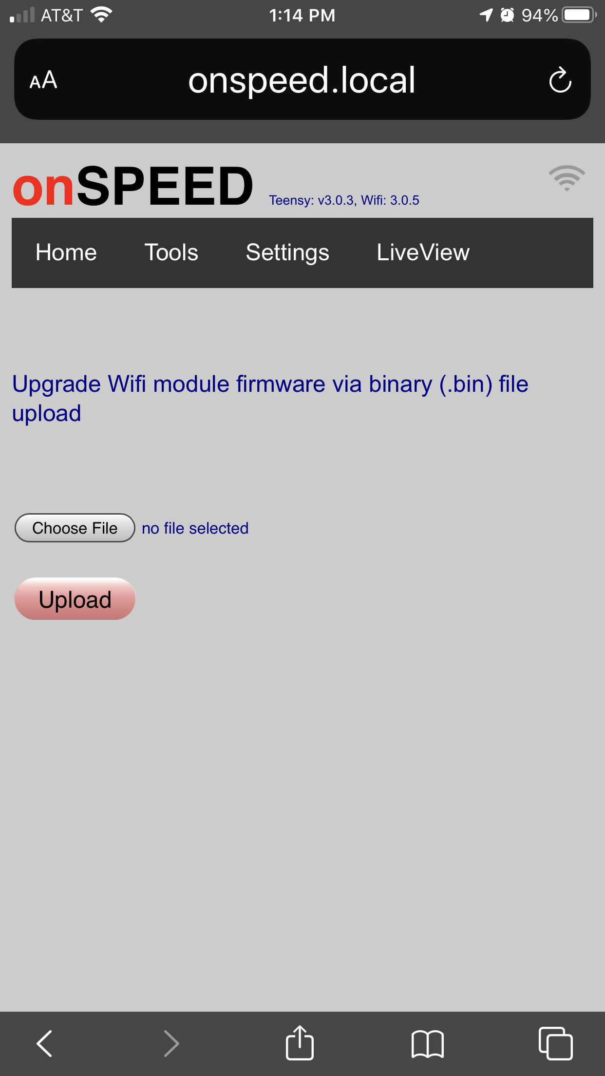

Select Browse.

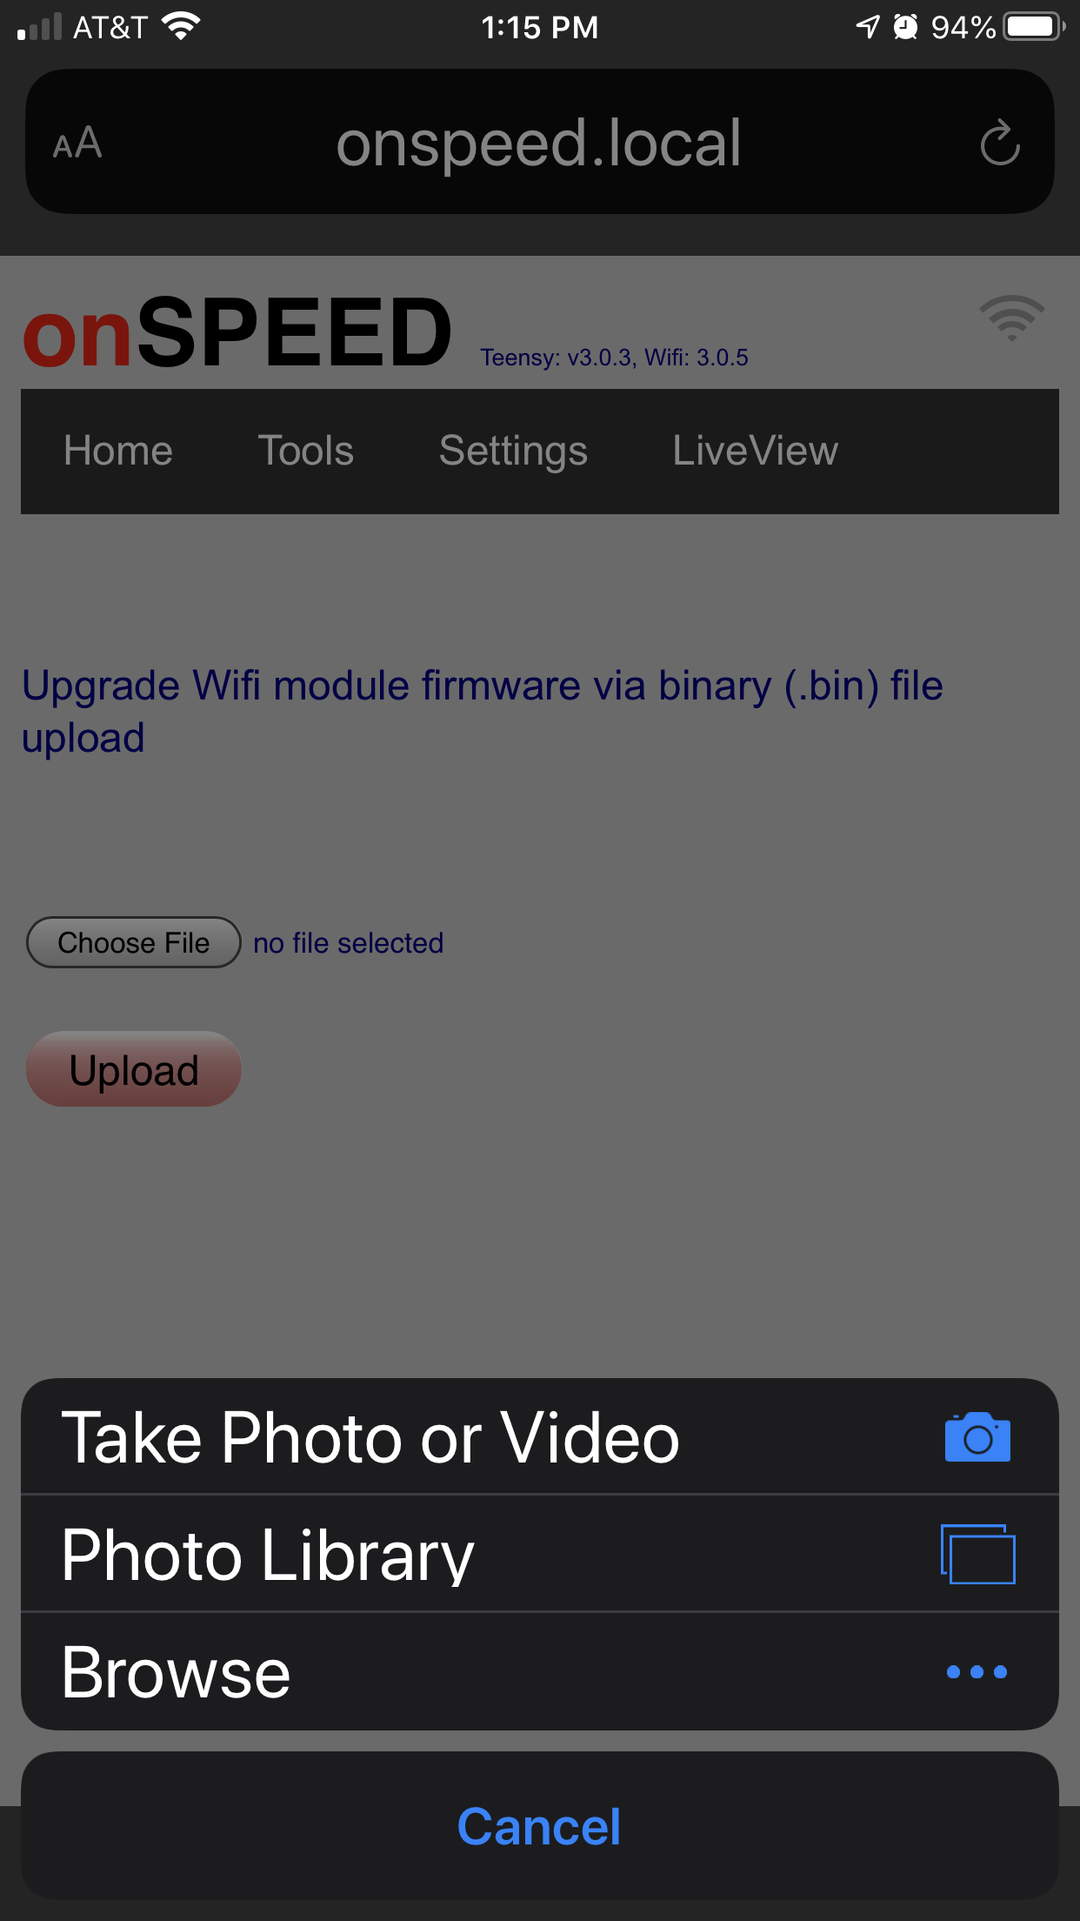

Select OnSpeedWifi.ino.pico32.bin file. Select Upload.

Wait for completion. You may need to power cycle your OnSpeed Gen 2 V3 device.

Refresh your iPhone browser window on the onspeed.local screen and you should see the latest version of Teensy and WiFi.

